Acceleration Due to Earth’s Gravity

Name: ____________________________

Step1: Download the video clip “Ball toss up” posted on eCampus along with this lab handout and save it on your computer.
Step 2: Download and install the latest version of the Tracker program from:
http://www.compadre.org/osp/items/detail.cfm?ID=7365
Step 3: Run the tracker program. Click on the “Video” tab on the menu bar and from the drop-down menu select “Import”. Use the “Look In” drop down menu to find the video clip that you had saved on your computer in Step 1, once you select the video clip, click on “Open”. It may take a few seconds to load the video.
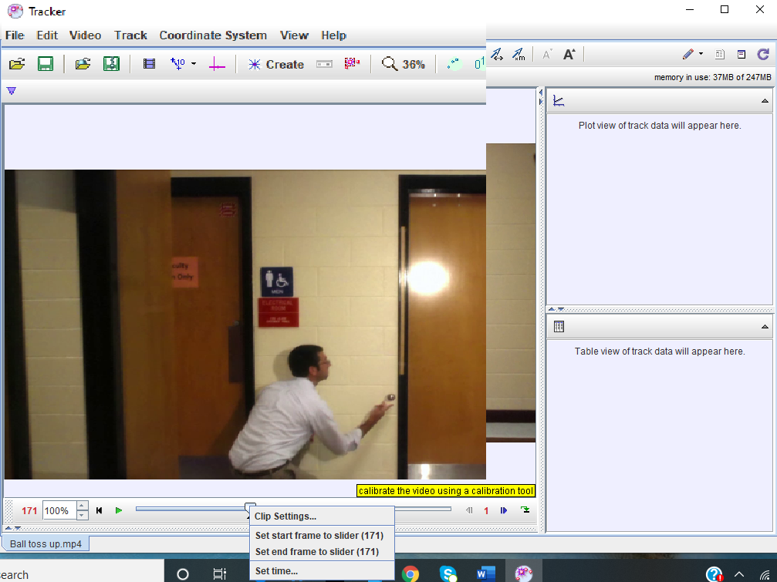
Step 4: Click on the green play button below the video to watch the clip in slow motion. Notice the frames number is displayed in red at the lower left corner as the frames pass in front of you.
Step 5: Once you have watched the video, drag the frame slider to the right until you get to the frame number 171. Notice that the ball has left the person’s hand in this frame. Right click on the slider and from the drop-down menu select “Set start frame to slider (171)”. You will notice an arrow appear below the slider at frame number 171. Now click on the sliding bar to the right of the slider and move through the frames until you get to the frame number 234. Right click on the slider and from the drop-down menu select “Set end frame to slider (234)”. This is where the ball is about to hit the floor. We are going to study the motion between frames 171 and 234 for this lab.
Step 6: Drag the slider back to frame number 171. Click on the coordinate axis symbol to set the origin from the experiment. This will display the origin somewhere random on the video. Drag the origin using your mouse and place it exactly at the center of the ball. The ball is rather small so it might be difficult to know exactly where the center is. To be precise, right click on the video near the ball and click on “Zoom in”, this will zoom into the video, set the origin at the center of the ball. Once done, click on the coordinate axis symbol on the top horizontal menu again, this will hide the coordinate axis.
Step 7: Staying zoomed in, click on the vertical bar to scroll up the video screen until the entire meter stick attached to the wall in the video (beside the door) is in your view.
Step 8: Click on the “calibration tools” icon and from the drop-down menu select “New > Calibration Stick”. Press the “Shift” key on your keyboard, it will start displaying a rectangular cross hair on the vide. Keeping the “Shift” key pressed, used the mouse to bring the cross hair to the top right-hand corner of the meter stick, once the center of the cross hair is exactly at the top right corner of the meter stick, release the “Shift” key. Again, press the “Shift” key and place the center of the cross hair exactly at the bottom right hand corner of the meter stick, once there, release the “Shift” key. Once you do that, a calibration stick will appear with a box that would show some number (like 451.0 m) as the length of the meter stick. Click on that number and change it to the actual length of the meterstick 1.0 m. This will serve as the scale for all the measurements in the video.
Step 9: Click on the “calibration tools” icon again, this will hide the calibration stick. Right click in the video and “Zoom Out”. Now we are ready to track the ball in the video frame by frame and see what kind of motion ball exhibits.
Step 10: Click on the “create” icon , and from the drop-down menu select “Point Mass”. This will start displaying a small “Take Control” box that has “mass A” selected in it. Click on “mass A” and select “Name…” from the drop-down menu. In the “Set Name” delete “Mass A” and type in “Ball”. We want to track the ball as accurately as possible, so right click on the video and click on “Zoom In”. After zooming in, if the ball is not in the view, you can scroll the frame up/down or left/right until it comes into the view.
Step 11: Press and hold the “Shift” key on your keyboard, a crosshair will appear, use your mouse to bring the center of the cross hair at the center of the ball (as accurately as possible), once the center of the cross hair is perfectly aligned with the center of the ball, release the shift key. Doing this will take the record the data for this frame and the next frame will appear, the ball will shift to the new position.
Step 12: Repeat step 11 for the new position of the ball. Keep repeating this step until you reach the frame number 234 (the last frame we want to analyze). You will data automatically being recorded into the table to the bottom right and a plot above the table.
Step 13: The plot’s vertical axis is labeled as “x(m)”, but we are interested in the motion along vertical direction or y-axis (since the ball goes up and then comes down), so click on the label “x(m)” and from the drop down menu click on “y: position y-component”. Now you will se the plot of the vertical motion of the ball s a function of time.
Step 14: Let’s fit the data to a mathematical function. Right click on the plot and from the drop-down menu select “Analyze”, a “Data Tool” window will appear. Click on the “Analyze” and check the box “Curve Fits”. Under the plot, there is a “Fit Name” drop down menu, select “Parabola” from this menu. The fit equation for the parabola will be displayed, it is:
y = A*t^2 + B*t + C (1)
Notice that the fit function curve goes nicely through the data points that you had collected for the ball’s vertical motion. Parameter values will also be displayed. Write down these values below:
A = -4.97E0
B = 4.775E0
C =-1.862E-2
Write equation (1) in the space below but with the parameter symbols A, B, and C replaced by their actual values, we will label it as equation (2).
y = (-4.97)*t^2 + (4.775)*t + (-0.01862) (2)
Take a picture or a screenshot of your plot along with the fit function parameters and paste it in the space below.

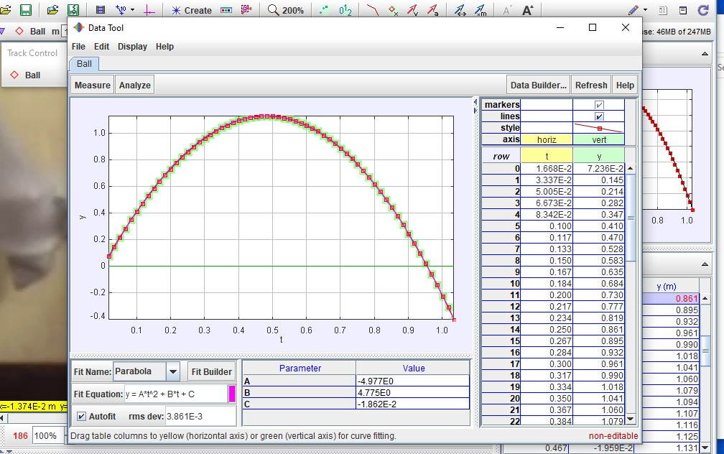

Step 15: In the lecture, we learned that the position as a function of time for free fall is described by the equation:
y_{f} = y_{i} + v_{i}t + (1/2)at² (3)
This is the same as equation (2) above but with variables “y_{i}”, “v_{i}”, and “(1/2)a” replaced with the actual values obtained from experiment. Compare each term in equation (2) with the corresponding term in equation (3) and write down the experimental values below:
y_{i} = -0.01862 v_{i} = 4.775 (1/2)a = -4.97
Step 16: Calculate the value of acceleration due to gravity “a” from this information. Show all your work below. It is a convention that we use the symbol g for this acceleration. “g” is positive but if the upward direction is assumed to be positive (like we did in this lab), the acceleration a is negative.
Experimental: a = - g = -9.94m/s²
Actual: g = 9.80665 m/s²
Step 17: Congratulations! You’ve just measured the acceleration due to gravity of the Earth. What is its percent error (as compared to the actual value of g), show all your work?
$$\% error= \left|\frac{g\left(actual\right)-g(experiment)}{g(atual)}\right| x 100$$
=
$$\% error= \left|\frac{9.80665-9.94}{9.80665}\right| x 100$$
= 1.35979157%
$\% error=$ 1.359%
Step 18: In the space below, draw the position versus time, velocity versus time and acceleration versus time graphs for an object dropped from a height of 10 m.
